- Scenario: You are developing a banking application that categorizes transactions based on the amount entered.
Write logic to determine whether the amount is positive, negative, or zero.
Ramishahope Artificial Intelligence Pvt Ltd
36, Old Anandas, SG Arcade, Marudhamalai Main Road, Vadavalli, Coimbatore -641041.
+91 6385383227 | www.hopelearning.net | mdaravind@hopelearning.net | 33AAMCR3722R1ZU
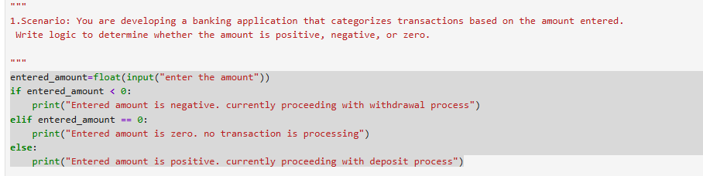
- Scenario: A digital locker requires users to enter a numerical passcode. As part of a security feature, the system checks the sum of the digits of the passcode.
Write logic to compute the sum of the digits of a given number.
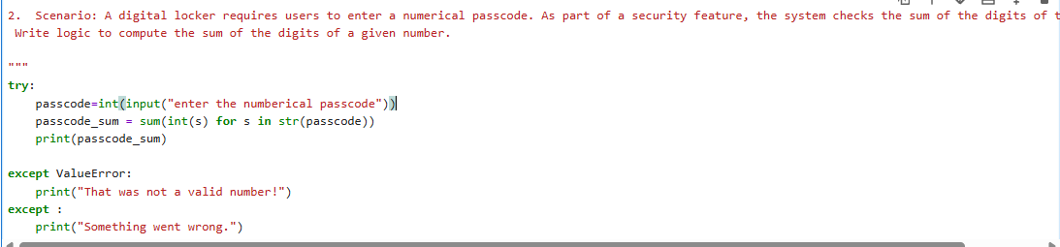
- Scenario: A mobile payment app uses a simple checksum validation where reversing a transaction ID helps detect fraud.
Write logic to take a number and return its reverse.
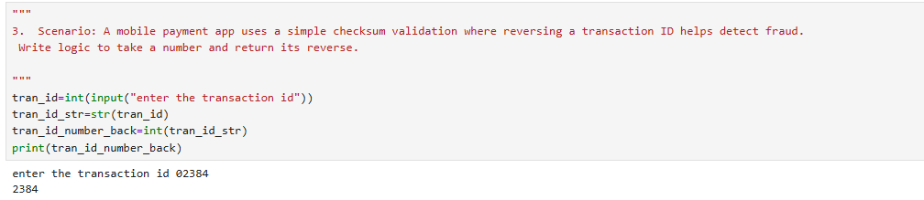
- Scenario: In a secure login system, certain features are enabled only for users with prime-numbered user IDs.
Write logic to check if a given number is prime.
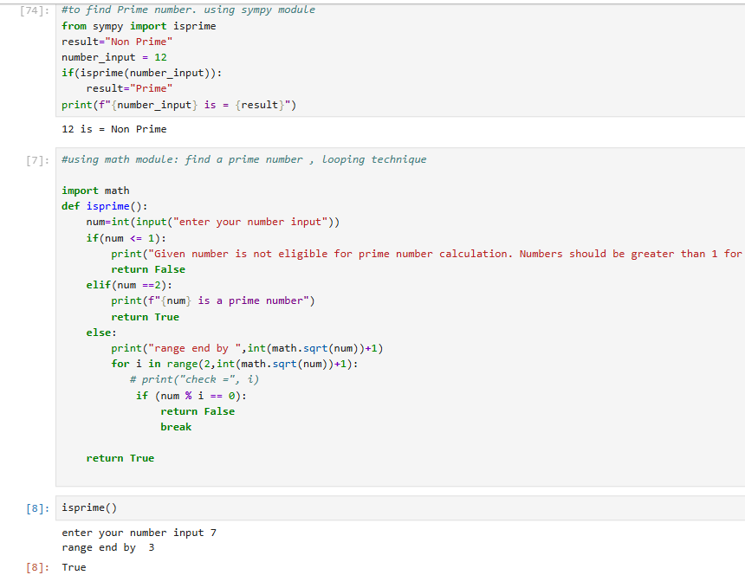
- Scenario: A scientist is working on permutations and needs to calculate the factorial of numbers frequently.
Write logic to find the factorial of a given number using recursion.
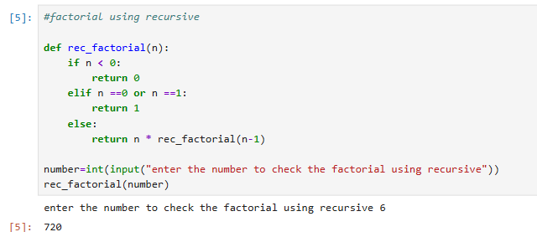
- Scenario: A unique lottery system assigns ticket numbers where only Armstrong numbers win the jackpot.
Write logic to check whether a given number is an Armstrong number.
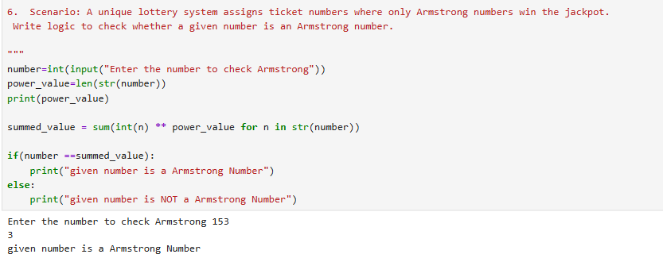
- Scenario: A password manager needs to strengthen weak passwords by swapping the first and last characters of user-generated passwords.
Write logic to perform this operation on a given string.

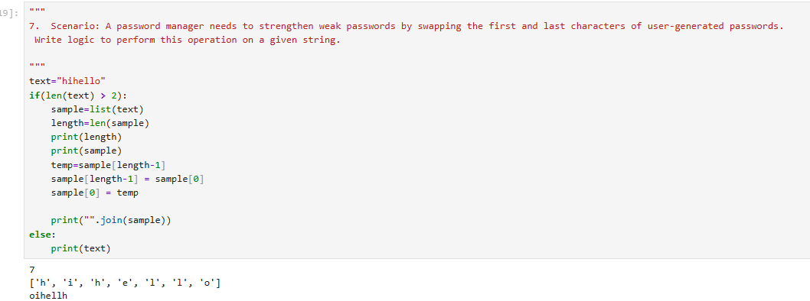

- Scenario: A low-level networking application requires decimal numbers to be converted into binary format before transmission.
Write logic to convert a given decimal number into its binary equivalent.
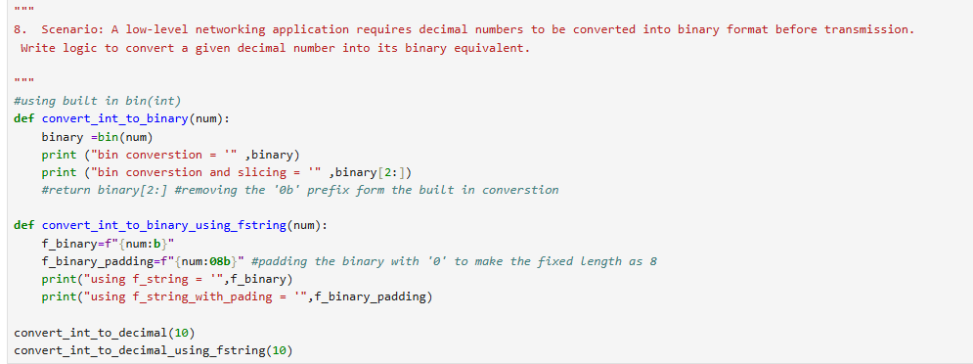
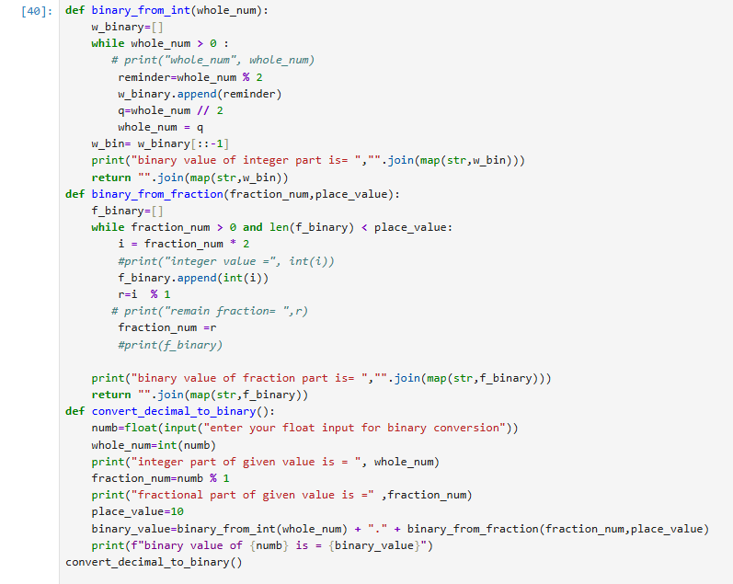
- Scenario: A text-processing tool helps summarize articles by identifying the most significant words.
Write logic to find the longest word in a sentence.
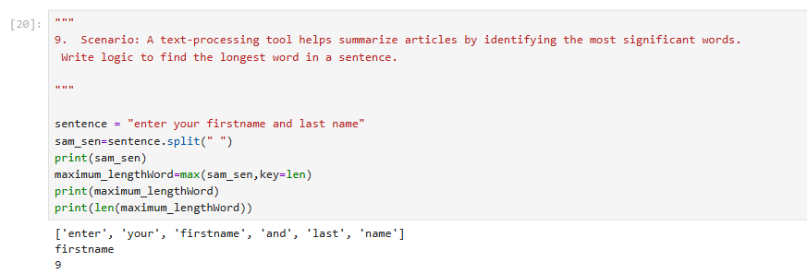
- Scenario: A plagiarism detection tool compares words from different documents and checks if they are anagrams (same characters but different order).
Write logic to check whether two given strings are anagrams.
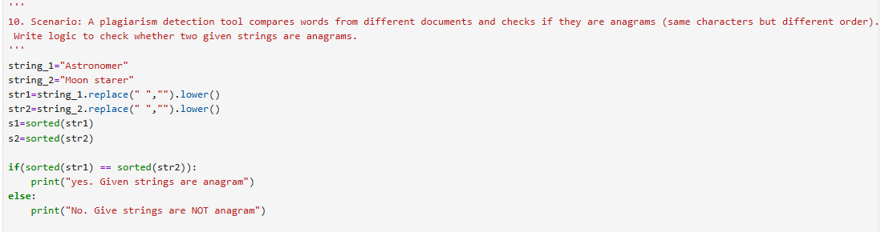

Ramishahope Artificial Intelligence Pvt Ltd
36, Old Anandas, SG Arcade, Marudhamalai Main Road, Vadavalli, Coimbatore -641041.
+91 6385383227 | www.hopelearning.net | mdaravind@hopelearning.net | 33AAMCR3722R1ZU

